Lab 8 - Set up skill-based routing in Unified Routing
Duration: 25 mins

Introduction
In this lab, you will learn how to create and configure skills, rating models, and skill-based routing in the Copilot Service admin center. Skill-based routing helps ensure that customer requests are automatically assigned to the most qualified agents based on their skills and proficiency levels. You will also learn how to assign newly created skills and rating values to agents.

Task 1: Create a New Skill
In this task, you will create a new skill named Spanish to define language proficiency for agents. This skill will later be used in routing logic to match customers with agents who possess the required language capability.
- In the Copilot Service admin center navigate to the site map and select User management under the Customer support group.
- On the User management page, select Manage next to Skills.
- 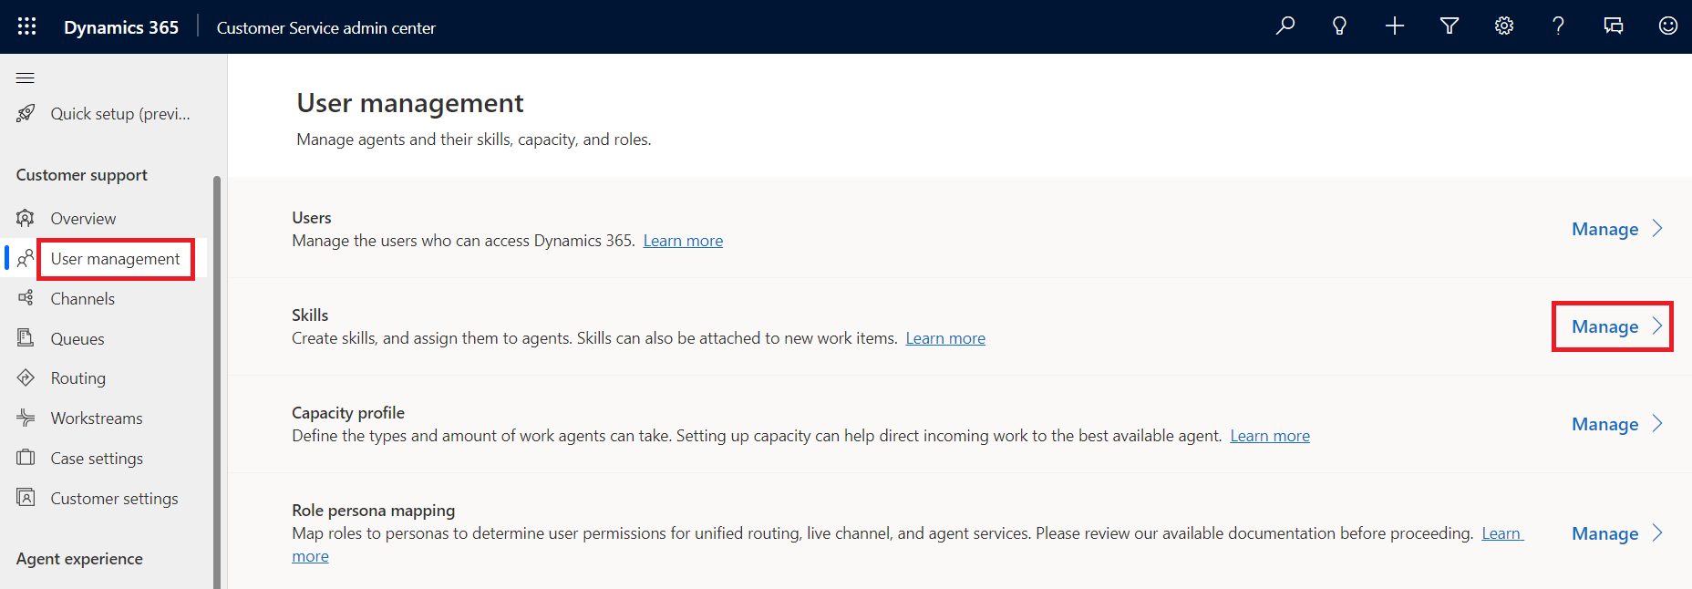
- Select + New to create new skill.
- 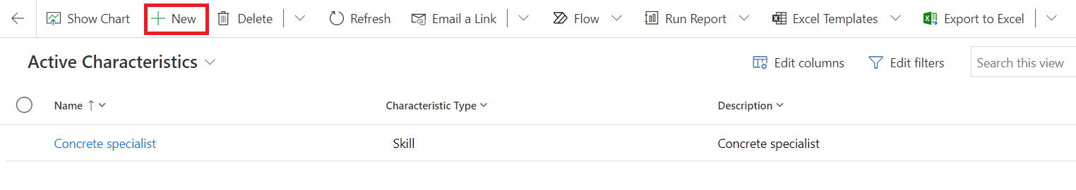
- Specify the following in the New Characteristic page.
- Name - !!Spanish!!
- Type - Skill
- Description - !!This record is used to define the skill level of the Spanish language!!
- Select Save & Close from top bar.
- 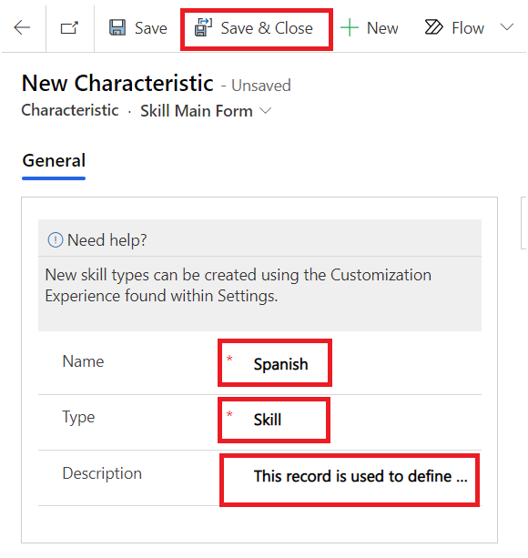

Task 2: Configure Skill-Based Routing and Rating Model
In this task, you will enable skill-based routing and create a Language rating model to define the range and levels of skill proficiency. You will also add a Language rating value to the model to rate agents based on their capabilities.
- In the Copilot Service admin center navigate to the site map and select Routing under the Customer support group.
- Select Manage next to the Skill-based routing.
- 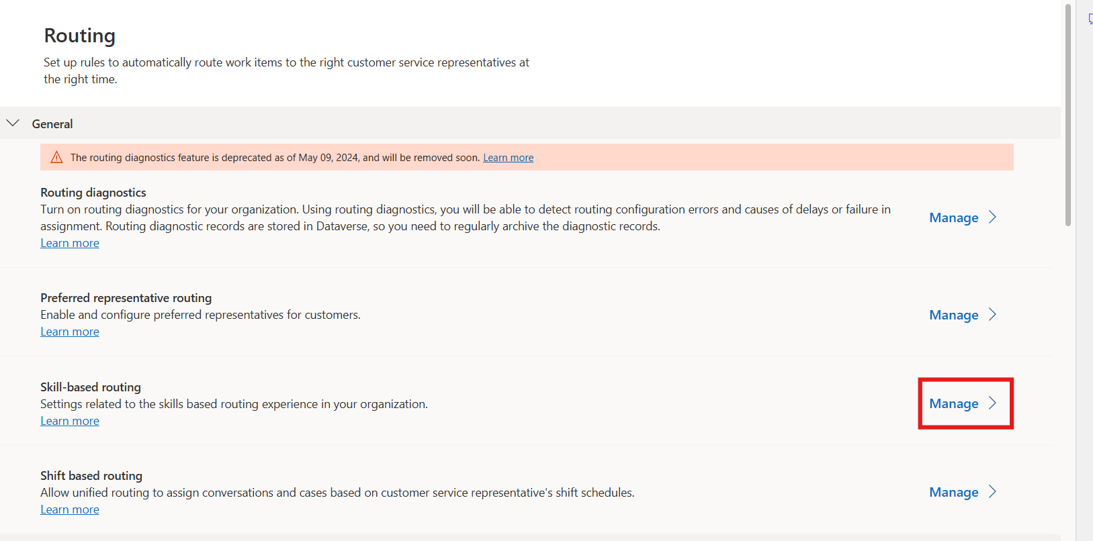
- On the Omnichannel Configuration page, set the toggle for Enable update skill control to Yes. In the Rating Model section, select + New Rating Model.
- 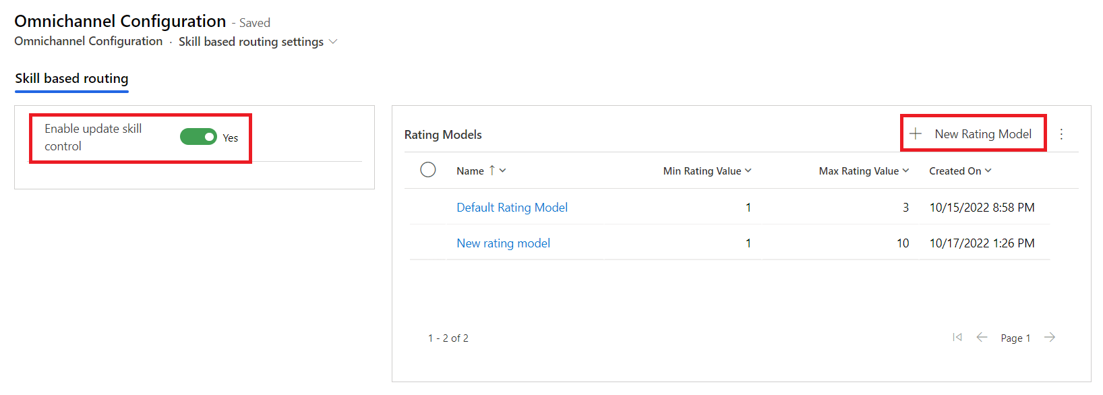
- Specify the following in the New Rating Model page.
- Name - !!Language rating model!!
- Min Rating Value - !!1!!
- Max Rating Value - !!10!!
- Select Save.
- 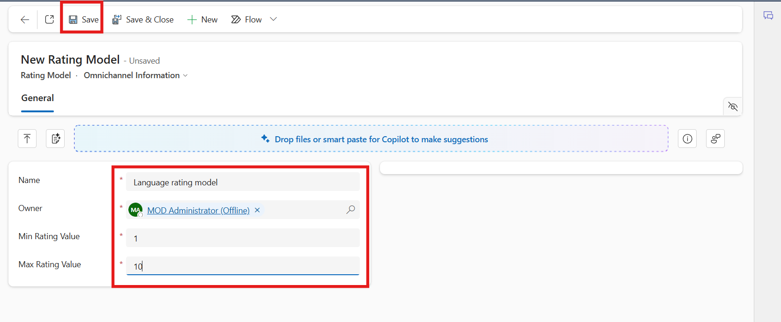
- The Rating Values section appears. Click on the vertical ellipsis and select + New Rating Value.
- 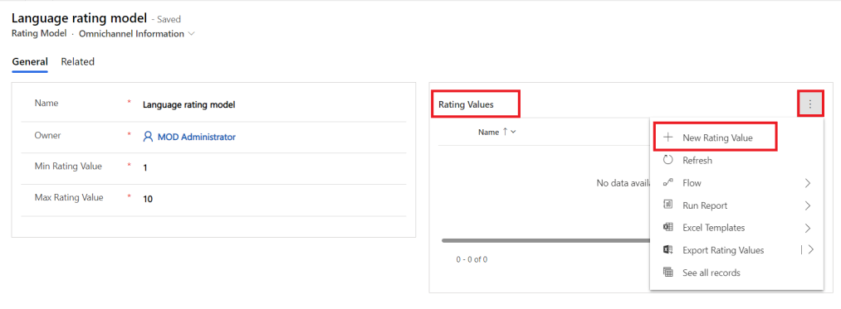
- The New Rating Value page appears.
- Specify the following.
- Name - !!Language rating value!!
- Value - !!10!!
- Select Save & Close to save and add the rating value to the grid.
- 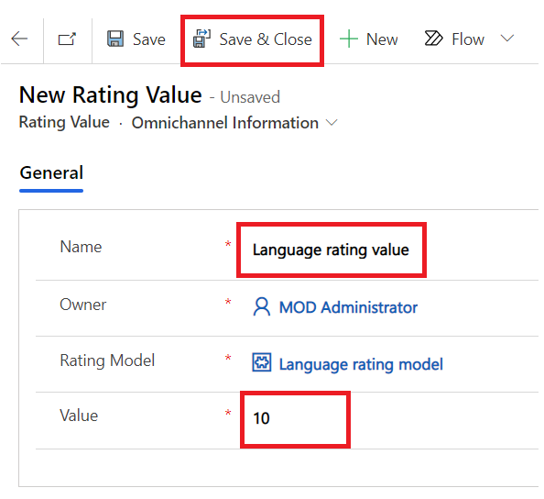
- Select Save & Close on the top of the languagerating model page to navigate back to the Omnichannel Configuration page.
- 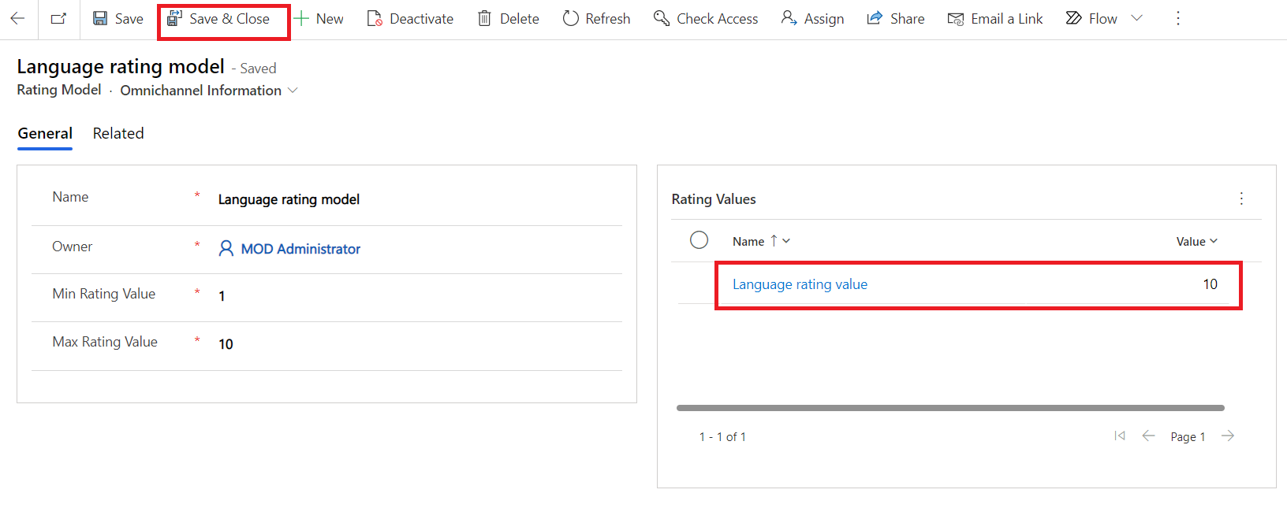
- On the Omnichannel Configuration page, click Save & Close
- 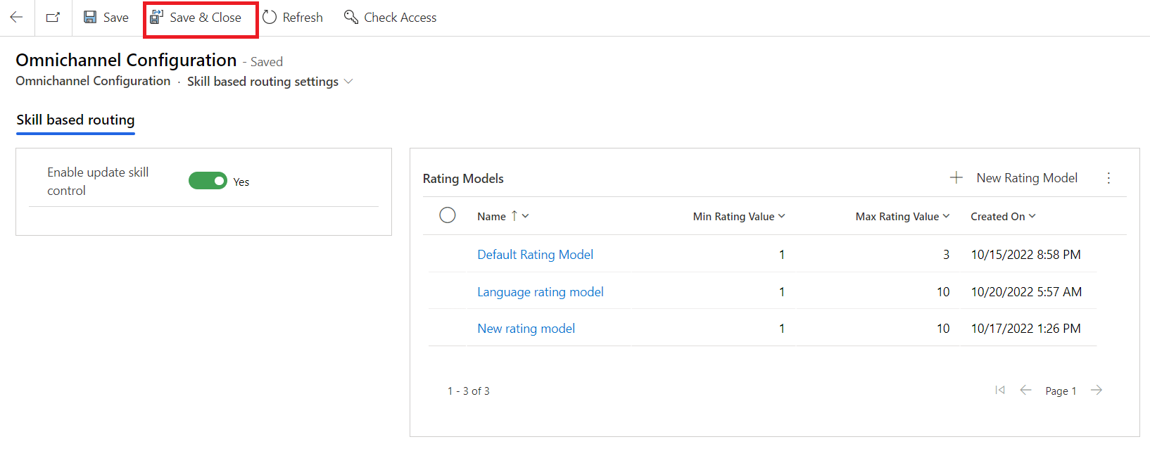

Task 3: Configure an Omnichannel User Profile
In this task, you will configure an Omnichannel user profile by updating the agent details for Mark Brown. You will view the agent’s working hours, save the configuration, and ensure the user is ready to be assigned skills.
- In Dynamics 365 Copilot Service admin center, in the site map, select User management under the Customer support group.
- On the User management page, select Manage next to Users.
- 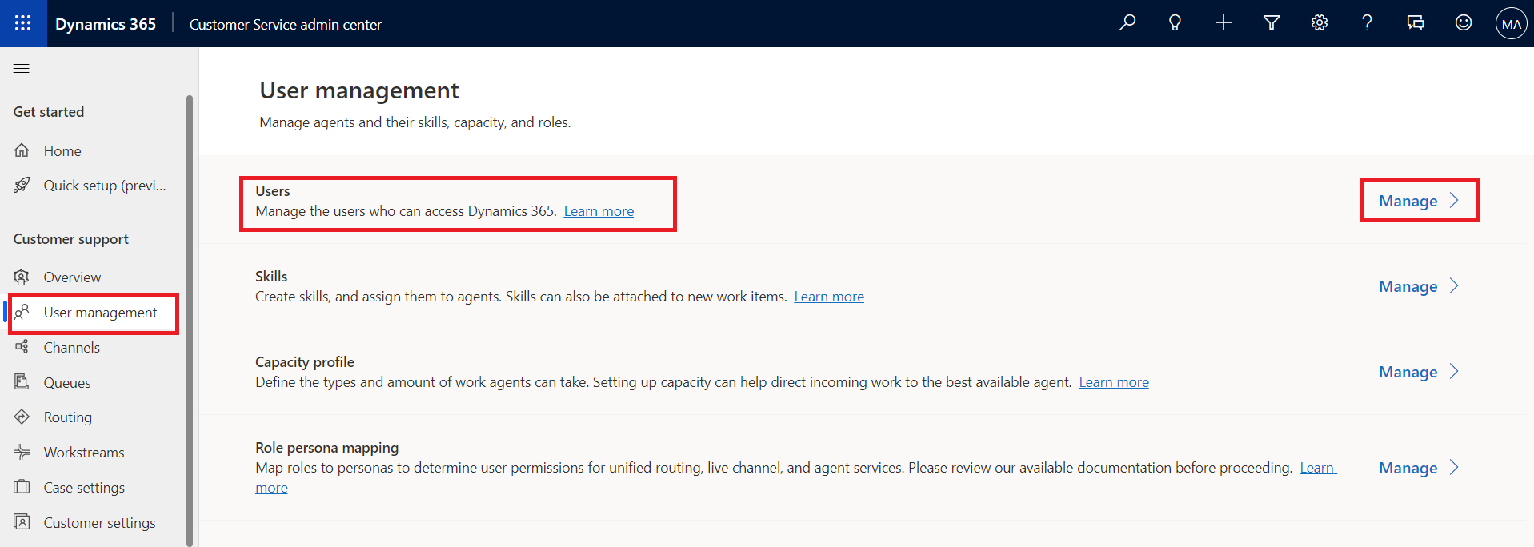
- Click the dropdown next to Enabled Users and select Omnichannel Users.
- 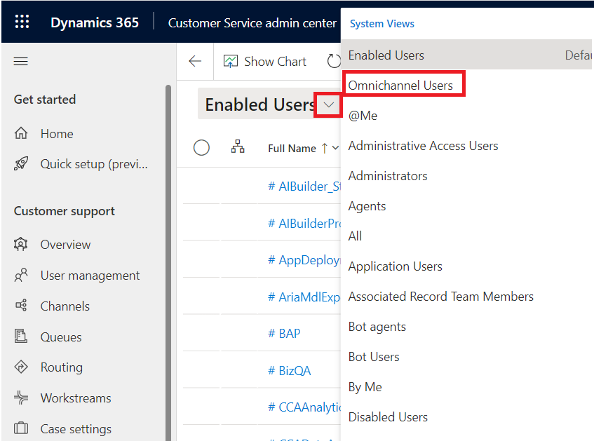
- On the Omnichannel Users page, select MOD Administrator from the list.
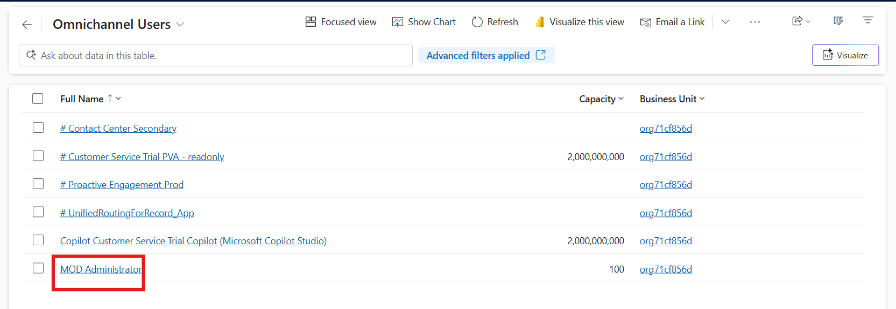
- Select the Omnichannel tab.
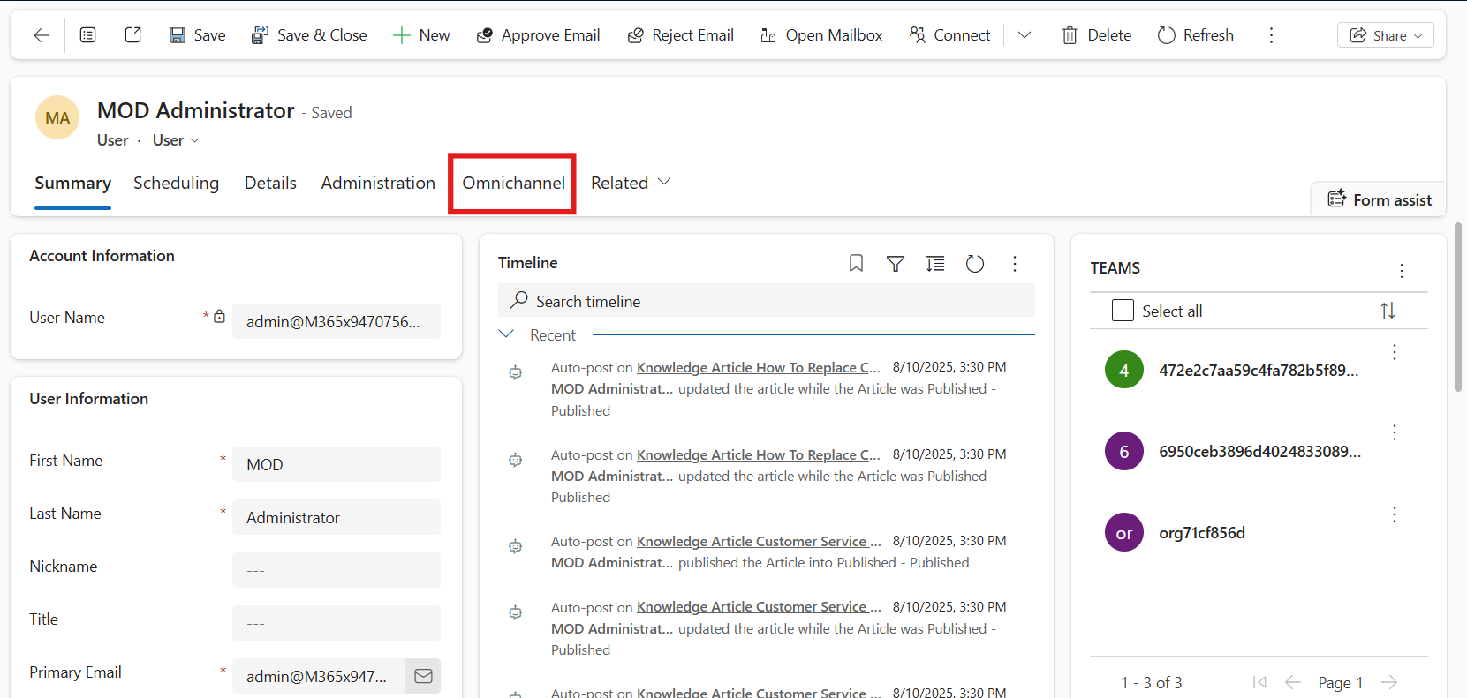
- Select Trial User under the Skills Configuration section.
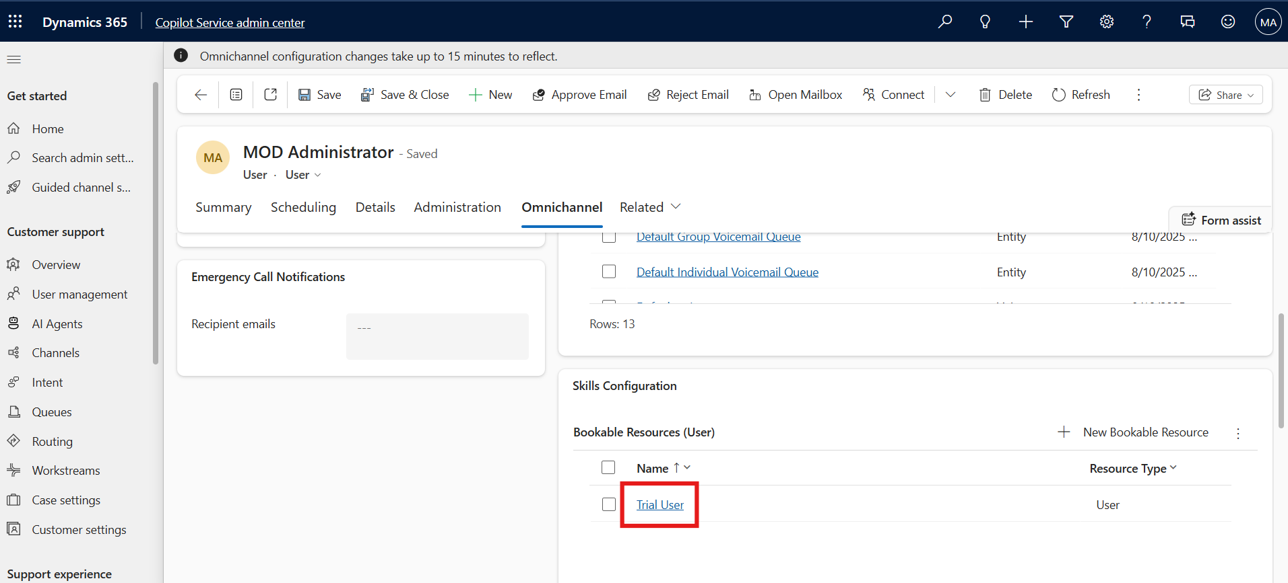
- On the New Bookable Resource page, change the Name to !!Mark Brown!!. Select Save.
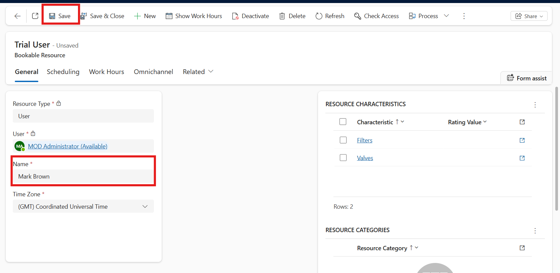
- Click the Work Hours tab to see the details of the agent Mark Brown.
- 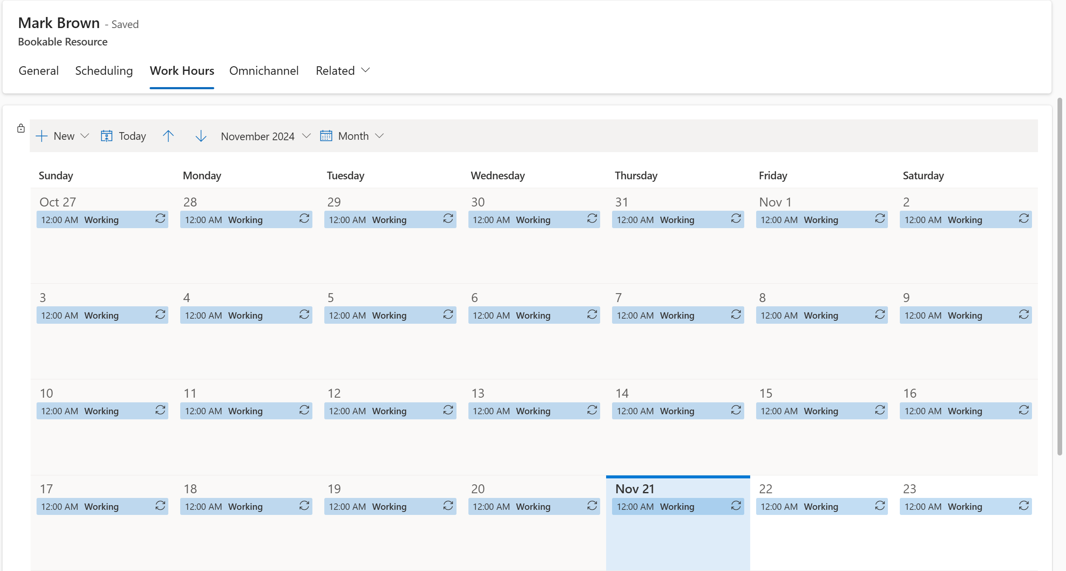
- Select the General tab and then select Save & Close to navigate back to your admin User page.
- 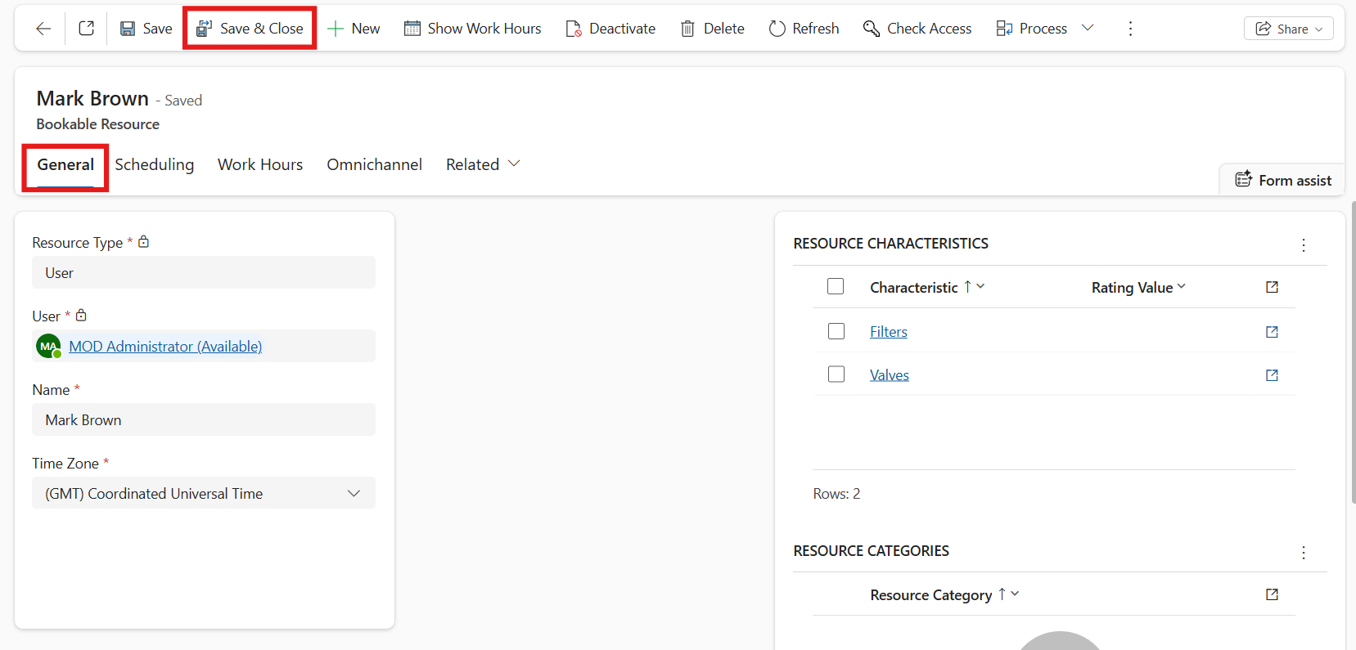
- On the MOD Administrator page, select Save & Close.
- 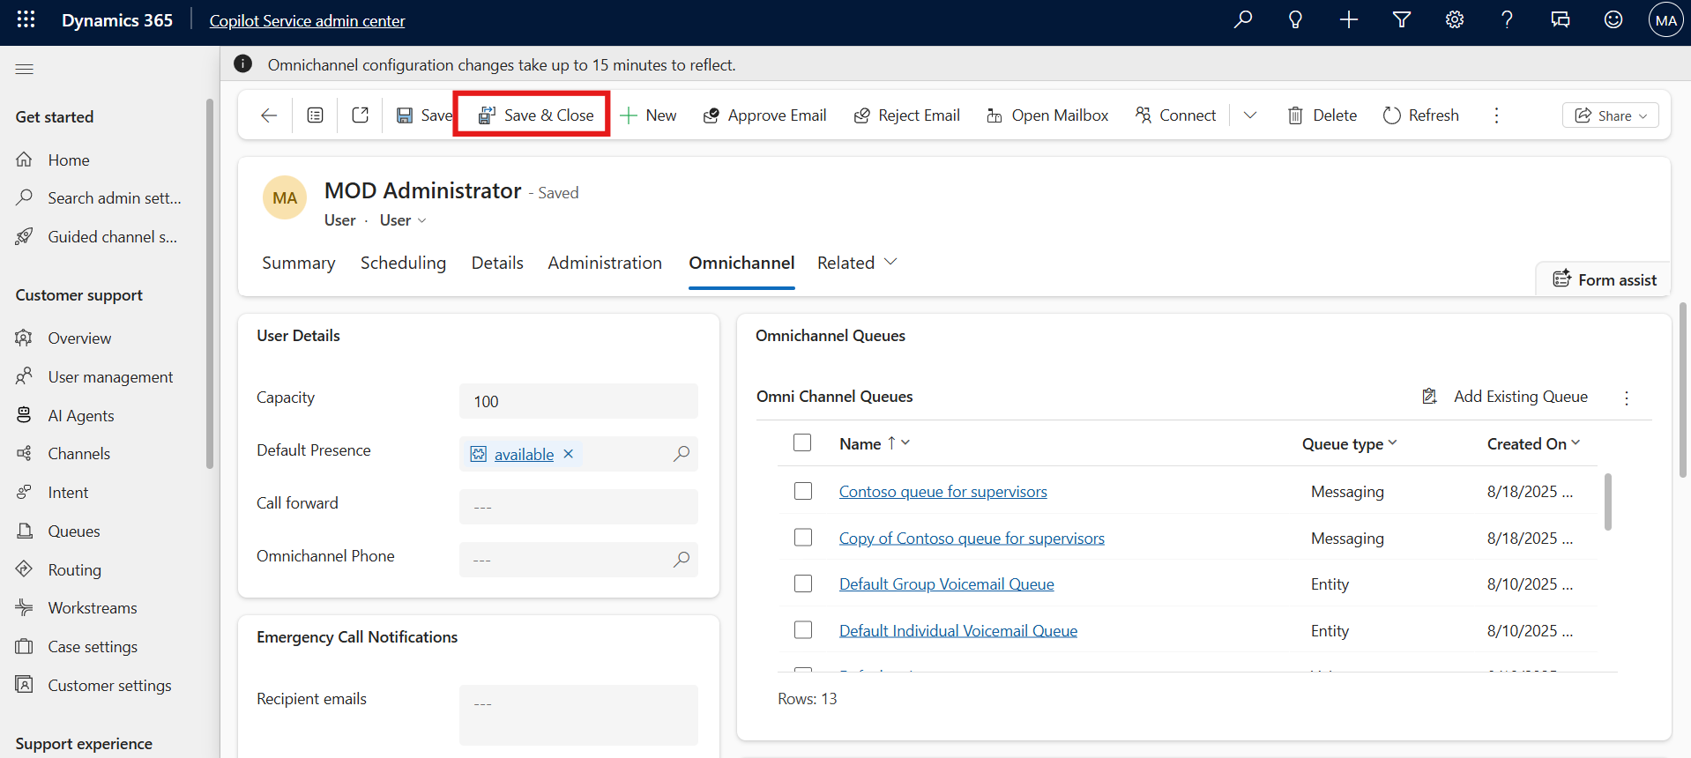

Task 4: Assign Skill and Rating Value to an Agent
In this task, you will assign the Spanish skill and the corresponding Language rating value to the agent Mark Brown. This allows the agent to handle customer interactions requiring Spanish language proficiency.
- In the Copilot Service admin center navigate to the site map and select User management under the Customer support group.
- On the User management page, select Manage next to Skills.
- Select the skill "Spanish" from the list for which you want to assign the agents.
- 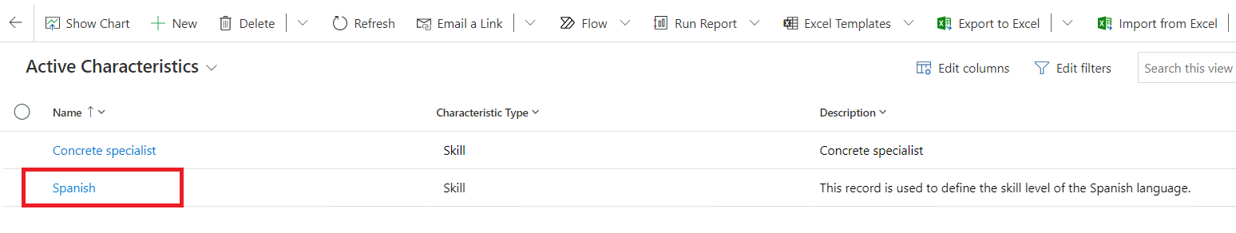
- Select + New Bookable Resource Characteristic in the Users (Agents) section.
- 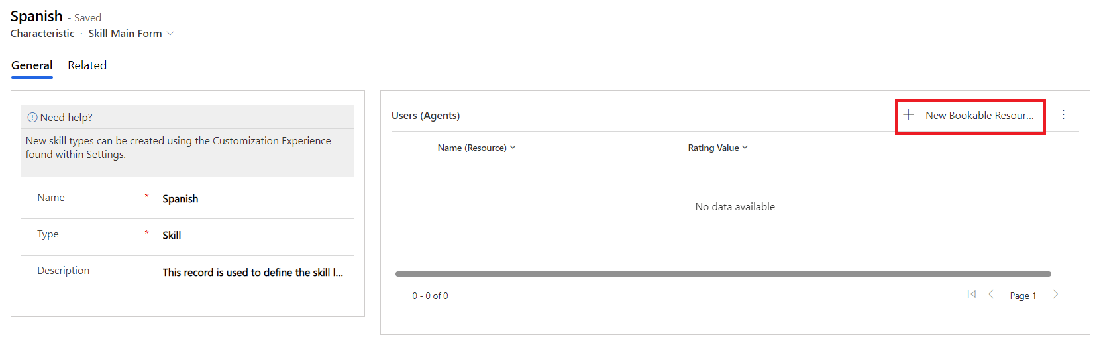
- On the New Bookable Resource Characteristic page, Click on the rating value field, press enter button and select Language rating value for the Rating Value field and select Mark Brown for the Resource field.
- Select Save and Close.
- 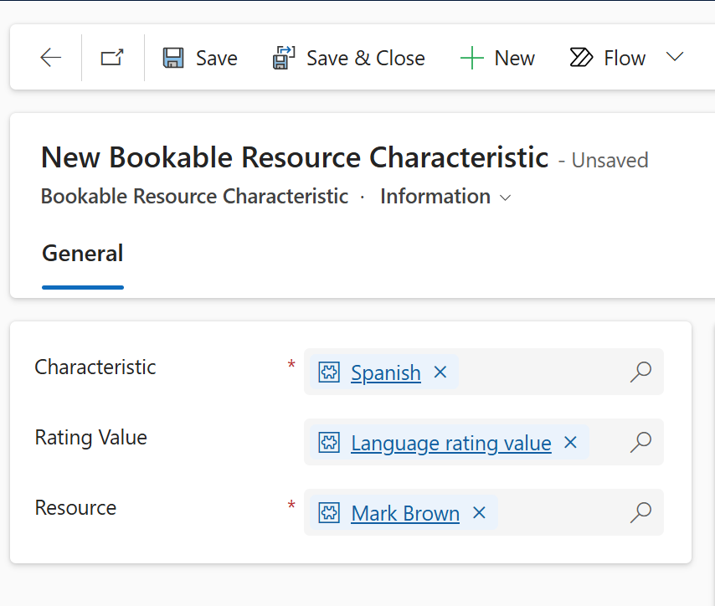
- On the Spanish Characteristic page, select Save.
- 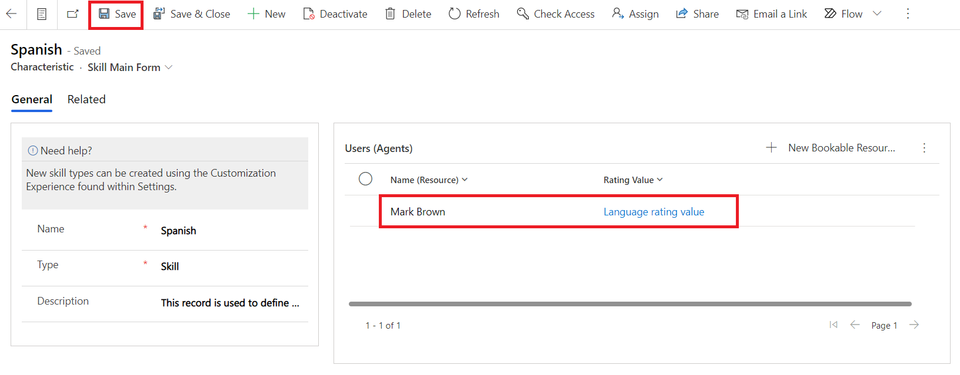

Conclusion
By completing this lab, you have successfully created a skill, configured a skill-based routing model, and assigned the skill to an agent with a defined rating value. These configurations enable Dynamics 365 Copilot Service to intelligently route customer requests to the most suitable agents, improving efficiency and customer satisfaction.

